FOR IMMEDIATE RELEASE
Press Contact:
Jayne Feldman
jfeldman@emailbrave.com
404-233-3993

HELLO, GORGEOUS! HELLO, ATLANTA!
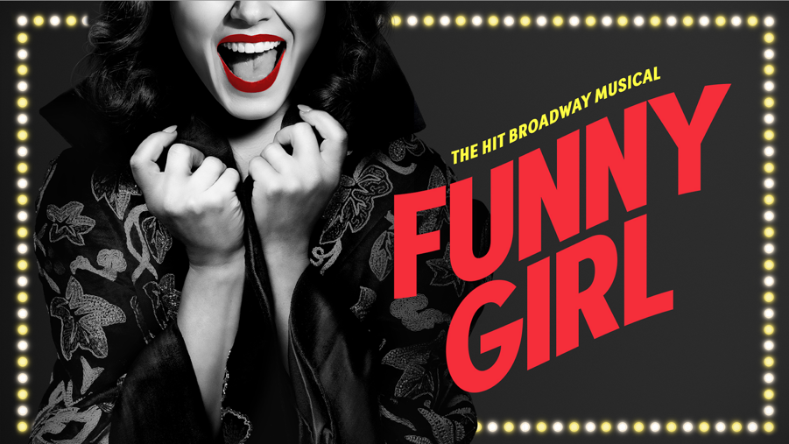
FUNNY GIRL IS COMING TO
ATLANTA, JULY 30 – AUG. 4
TICKETS ON SALE MAY 3
ATLANTA (APRIL 16, 2024) — FUNNY GIRL, the sensational musical comedy revival, is coming to Atlanta’s Fox Theatre for a limited one-week engagement from July 30 - Aug. 4 as part of the Regions Bank Broadway in Atlanta 2023/2024 season. Single tickets go on sale May 3 at 10 a.m. at the at the Fox Theatre box office at 660 Peachtree Street NE, by visiting foxtheatre.org/FunnyGirl or by calling 855-285-8499. Group orders of 10 or more may be placed by contacting sales@foxtheatre.org.
FUNNY GIRL will play for a limited one-week engagement in Atlanta from July 30 - Aug. 4. The performance schedule is:
Tuesday – Thursday 7:30 p.m.
Friday 8 p.m.
Saturday 2 p.m., 8 p.m.
Sunday 1 p.m., 6:30 p.m.

Welcome to musical comedy heaven! The “vivacious and delightfully glitzy” (Vogue) Broadway revival features iconic songs, including “Don’t Rain On My Parade,” “I’m the Greatest Star,” and “People.” Breaking box office records week after week and receiving unanimous raves on Broadway, this bittersweet comedy is the story of the indomitable Fanny Brice. As a girl from the Lower East Side who dreamed of a life on the stage, everyone told her she’d never be a star, but then something funny happened—she became one of the most beloved performers in history, shining brighter than the brightest lights of Broadway. The Observer describes the revival as “sparkling and explosively entertaining!”
FUNNY GIRL is directed by Tony® Award winner Michael Mayer (Thoroughly Modern Millie) and features the classic score by Tony, Grammy®, and Academy® Award winner Jule Styne and lyrics by Tony Award nominee and Grammy Award winner Bob Merrill, (comprising additional songs from Styne & Merrill). The original book by Isobel Lennart, from an original story by Miss Lennart, is revised by Tony Award winner Harvey Fierstein (Kinky Boots, Newsies).
FUNNY GIRL features choreography by Ellenore Scott (Falsettos); tap choreography by Ayodele Casel; scenic design by Tony Award winner David Zinn (SpongeBob SquarePants: The Musical); costume design by Tony Award winner Susan Hilferty (Wicked); lighting design by Tony Award winner Kevin Adams (Hedwig and the Angry Inch); sound design by Tony Award winner Brian Ronan (Beautiful: The Carole King Musical) and Cody Spencer; hair and wig design by Campbell Young Associates; music supervision by Emmy Award winner Michael Rafter; casting by Jim Carnahan, CSA, and Jason Thinger, CSA; orchestrations by Chris Walker; dance, vocal, and incidental music arrangements by Alan Williams, and additional arrangements by David Dabbon and Carmel Dean. The associate director is Johanna McKeon; the associate choreographer is Jeffrey Gugliotti; the assistant director is Torya Beard; the assistant tap choreographer is Dre Torres.
The FUNNY GIRL tour stage management team is led by Production Stage Manager Jovon E. Shuck and is supported by Stage Manager Mariah Young and Assistant Stage Manager Rachael Wilkin. The company management team is led by Company Manager Justin Sweeney with Associate Company Manager Ryan Mayfield. The tour music director/conductor is Elaine Davidson.
The Broadway production of FUNNY GIRL began performances at the August Wilson Theatre on March 22, 2022, with the official opening on April 24, 2022, where it continued its record-breaking run through September 3, 2023. Sonia Friedman, Scott Landis, and David Babani together with Gemini Theatrical, Accidental Jacket, and Sony Masterworks Broadway released FUNNY GIRL – New Broadway Cast Recording, which is now available wherever you stream music. Produced by David Caddick and David Lai and featuring the classic score by Jule Styne (music) and Bob Merrill (lyrics), the album is co-produced by Sonia Friedman, Scott Landis, David Babani, Michael Mayer, Brian Gillet, Huck Walton, Sean Keller, and Marc Levine. The album is executively produced by Evan McGill and the associate producers are Joanna Drowos, Abby Green, and PickleStar Theatricals.
For more information, visit funnygirlonbroadway.com. Follow FUNNY GIRL on Facebook, TikTok, X, and Instagram.
###
The John Gore Organization is the leading presenter, distributor, and marketer of Broadway theater worldwide. Under the leadership of 20-time Tony-winning theater producer and owner John Gore, its family of companies includes Broadway Across America, Broadway.com, The Broadway Channel, BroadwayBox.com, Group Sales Box Office and Broadway Brands. The company presents shows in 48 cities across North America as well as on Broadway, Off-Broadway, London’s West End, Japan, and China. It has won Tony Awards in every producing category as well as numerous other Drama League, Drama Desk and Olivier Awards. The John Gore Organization is committed to supporting theater access and education programs that introduce Broadway to the next generation of audiences and theater professionals.
Broadway Across America (BAA) is part of the John Gore Organization family of companies, which includes Broadway.com, The Broadway Channel, BroadwayBox.com, Group Sales Box Office and Broadway Brands. Led by 20-time Tony-winning theater producer John Gore (Owner & CEO), BAA is the foremost presenter of first-class touring productions in North America, operating in 48 markets with over 400,000 subscribers. Presentations include Disney’s The Lion King, Wicked, The Book of Mormon and Hamilton. Current and past productions include Ain’t Too Proud, Beautiful, Cats, Chicago, Dear Evan Hansen, Mean Girls, Moulin Rouge! and To Kill A Mockingbird.

